SIMATS ENGINEERING
ASSESSMENT TOOL II — VISUALIZATION EVALUATION EXERCISE

Course: Data Handling and Visualization | Code: DSA0603 | CO: CO4
Duration: 60 min | Total Marks: 50 | Reg No: 192324275  Name:JAANA NITHISH

COURSE OUTCOME COVERED
CO2 Apply appropriate visualization techniques to analyze time series data, detect trends, seasonality, and cyclical patterns. (BL3)
Activity Tool : Visualization Evaluation Exercise Weightage: 20%

Code of Conduct:
I JAANA NITHISH(192324275) certify that this submission is my original work and that I have adhered to the guidelines specified for this assessment. I understand that any violation of academic integrity rules will result in disciplinary action.

Signature of the student: JAANA NITHISH

Criter ia | Evaluati on of Visualiz ation Quality  25% | Critical Analysis 25% | Applicat ion of Visualiz ation Principle s  20% | Organi zation 15% | Accura cy 10% | Clarity 5% | Total
Q1
Q2
Q3
Q4

Q5

Visualization Evaluation Exercise
Topic: Visualizing Time Series and Trends (Individual Time Series, Multiple Time Series & Dose–Response Curves, STL Decomposition, Smoothing, Detrending, Forecasting, Cycle & Seasonality Detection)

Provided Datasets
The following files are supplied alongside this document so the exercise can be completed without internet access. All are real, publicly documented datasets:
- AirPassengers.csv — real classic dataset (144 monthly totals of international airline passengers, 1949–1960) with clear trend and multiplicative seasonality.
- co2_mauna_loa.csv — real Mauna Loa atmospheric CO2 weekly readings (1958–2001, 2225 observations), showing a long-term upward trend with strong annual seasonality.
- Nile.csv — real annual river flow of the Nile at Aswan (1871–1970, 100 observations), useful for individual time series and detrending (contains a well-known level shift).
- sunspots.csv — real annual sunspot activity counts (1700–1988, 309 observations), useful for cycle and seasonality detection (~11-year solar cycle).
- EuStockMarkets.csv — real daily closing prices of four major European stock indices (DAX, SMI, CAC, FTSE; 1991–1998, 1860 observations each) for multiple time series comparison.
- ryegrass_doseresponse.csv — real dose–response data (root length of ryegrass vs. herbicide concentration, 24 observations) from the drc package in R.

Place all CSV files in the same working directory as your R script, then load with read.csv("filename.csv").

Question 1: Individual Time Series & Moving-Average Smoothing
Dataset provided: Nile.csv
Using the Nile dataset, convert the value column into an R ts object (start = 1871, frequency = 1) and plot the raw annual flow as a line chart. Overlay a smoothed version of the series using a moving average (e.g., a 5-year moving average via stats::filter() or zoo::rollmean()). Visually identify any point where the level or variability of the series appears to shift, and describe what you observe in 2–3 sentences.
Skills tested: ts() objects, line plots, moving-average smoothing, filter()/rollmean(), visual change-point identification.
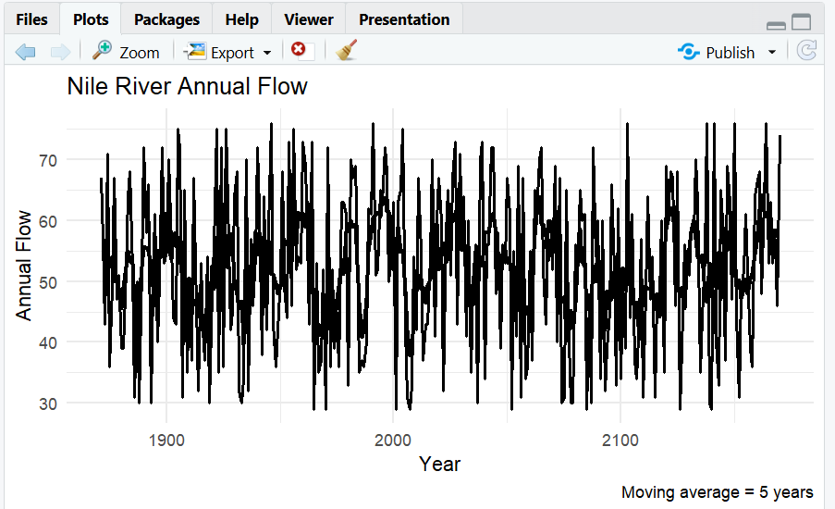

Observation
- The Nile flow fluctuates considerably from year to year, but the moving average shows the overall long-term pattern more clearly.
- A noticeable level shift occurs around 1898–1900, with the average flow becoming generally lower after the shift.

Question 2: Multiple Time Series Comparison & Dose–Response Curve This question has two parts.
Part a — Multiple Time Series
Dataset provided: EuStockMarkets.csv
Plot all four stock indices (DAX, SMI, CAC, FTSE) on the same time axis using ggplot2 (reshape to long format with tidyr::pivot_longer() first). Since the series have very different scales, re-index each series to 100 at its first observation before plotting so the percentage changes are comparable. Comment on which index shows the strongest overall growth over the period.
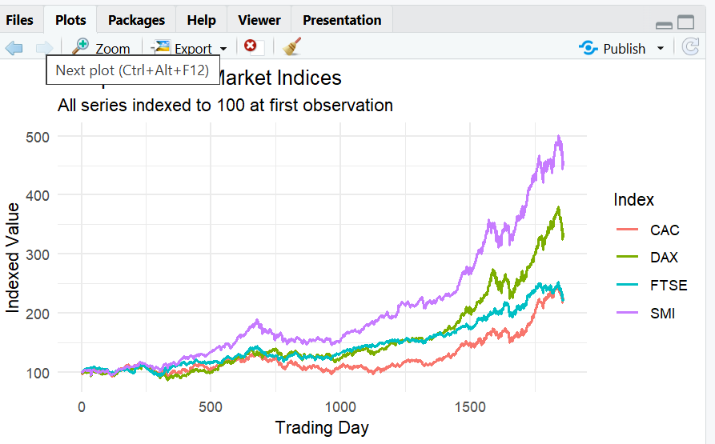

Part b — Dose–Response Curve
Dataset provided: ryegrass_doseresponse.csv
Plot root_length against concentration as a scatterplot, then fit and overlay a smooth dose–response curve (e.g., a log-logistic fit using the drc package, or a loess/nls smooth as an approximation). Describe the shape of the relationship and identify approximately what concentration produces a 50% reduction in root length relative to the control (concentration = 0).
Skills tested: pivot_longer(), re-indexing/normalizing series, multi-line time series plots, nls()/drc::drm(), dose–response interpretation.
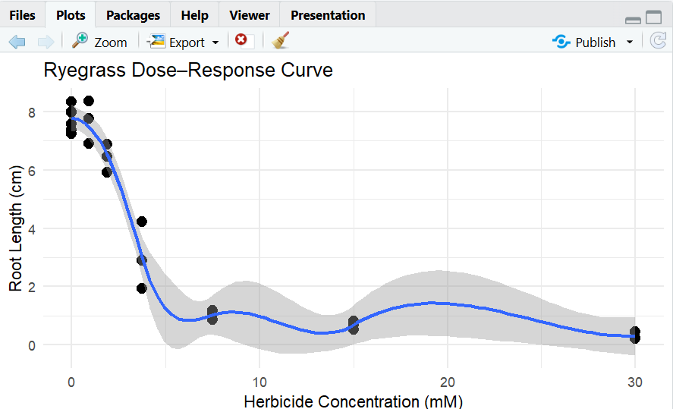

Interpretation
- Root length generally decreases as herbicide concentration increases.
- The dose–response curve therefore has a negative/sigmoidal relationship.
- The concentration corresponding to approximately half the control root length represents an approximate 50% effective concentration.
Question 3: Seasonal Decomposition of Time Series (STL)
Dataset provided: AirPassengers.csv
Convert the passengers column into a ts object (start = c(1949,1), frequency = 12). Apply STL decomposition using stl() (set s.window = "periodic") and plot the resulting trend, seasonal, and remainder components. Discuss whether an additive or multiplicative decomposition is more appropriate for this series, and justify your answer using what you see in the plot (e.g., whether seasonal amplitude grows with the trend).
Skills tested: ts() with frequency, stl(), additive vs. multiplicative decomposition, component interpretation.
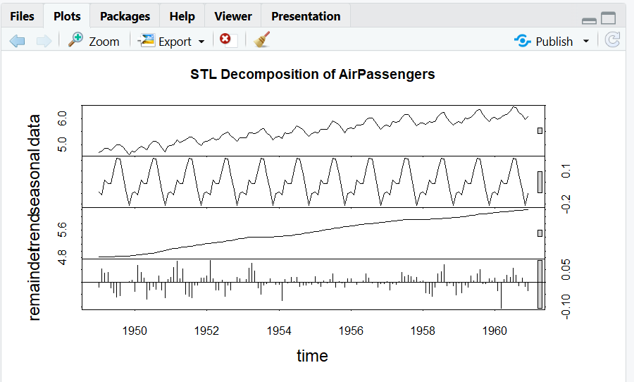

Interpretation
- The trend shows a strong long-term increase in passenger numbers.
- Seasonal fluctuations become larger as the number of passengers increases.
- Therefore, a multiplicative decomposition is more appropriate than a simple additive decomposition.
- Taking log() converts the multiplicative structure into an approximately additive one before STL.

Question 4: Detrending and Residual Analysis
Dataset provided: co2_mauna_loa.csv
Using the CO2 dataset, fit a linear trend (co2 ~ time) and subtract the fitted values from the observed series to obtain a detrended series. Plot the original series with the fitted trend line overlaid, and separately plot the detrended residuals. Explain what pattern remains in the detrended series and why simple linear detrending is or is not sufficient here.
Skills tested: lm() trend fitting, detr ending by residuals, two-panel diagnostic plots, interpreting leftover seasonal stru
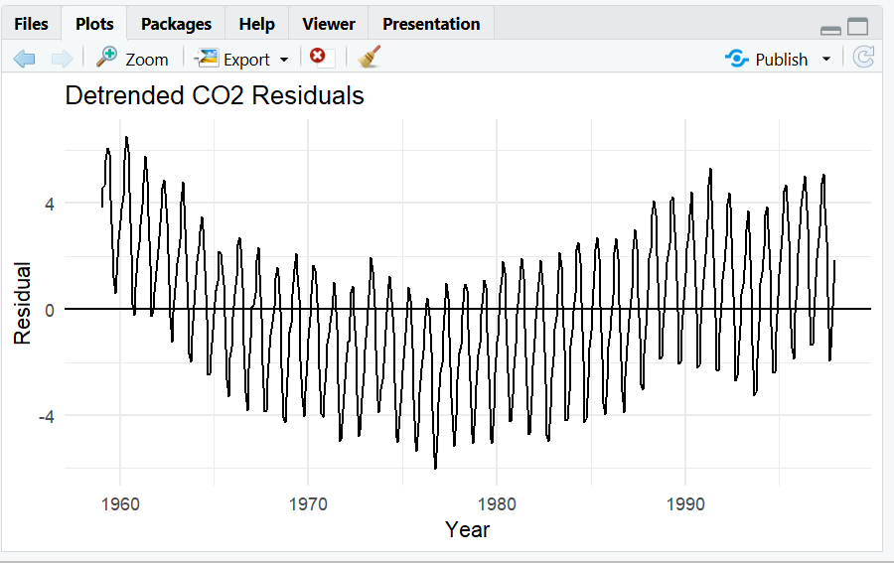
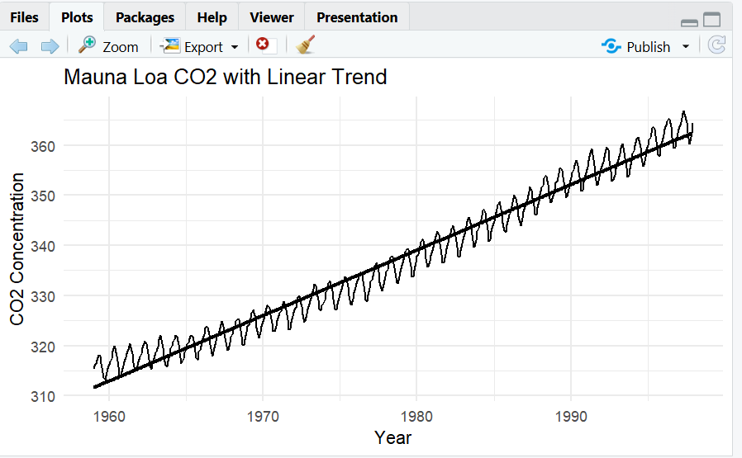

Interpretation
- The original CO2 series has a strong upward long-term trend.
- After removing the linear trend, a clear repeating annual seasonal pattern remains.
- Therefore, simple linear detrending is not sufficient to completely remove the systematic structure because CO2 contains strong yearly seasonality.
- A seasonal model or decomposition would be more appropriate.
Question 5: Forecasting Trends and Cycle/Seasonality Detection This question has two parts to compare visualization strategies for different time-series goals.
Part a — Forecasting Trends
Dataset provided: AirPassengers.csv
Using the forecast package (or fable), fit an ETS or auto.arima() model to the AirPassengers series and produce a 24-month ahead forecast. Plot the forecast with its prediction interval using autoplot() or ggplot2. Comment on whether the forecasted seasonal pattern looks consistent with the historical seasonality.
Part b — Cycle and Seasonality Detection
Dataset provided: sunspots.csv
Using the sunspots dataset, compute and plot the autocorrelation function (ACF) using acf(), and/or a periodogram using spectrum(). Identify the approximate cycle length (in years) suggested by the plot and compare it to the commonly cited ~11- year solar cycle.
Skills tested: forecast::ets()/auto.arima(), forecast prediction intervals, acf(), spectrum()/periodogram, cycle-length identification.
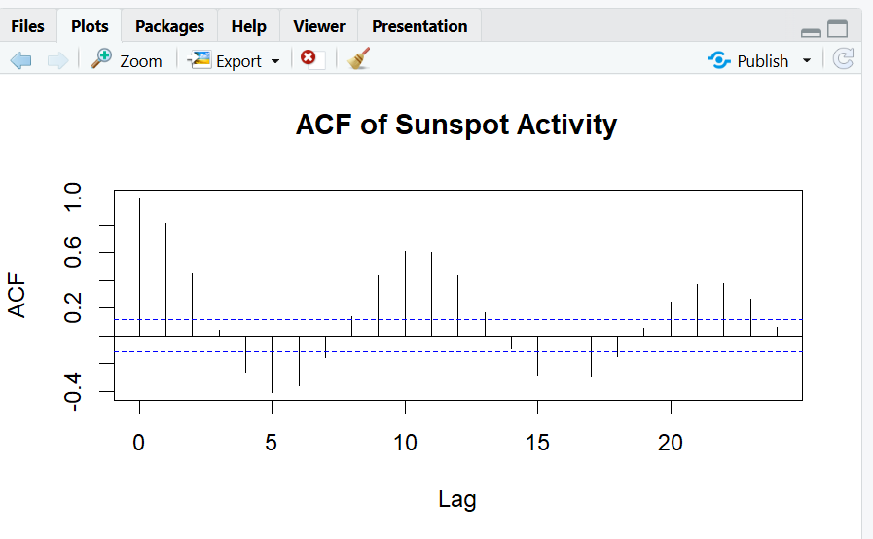
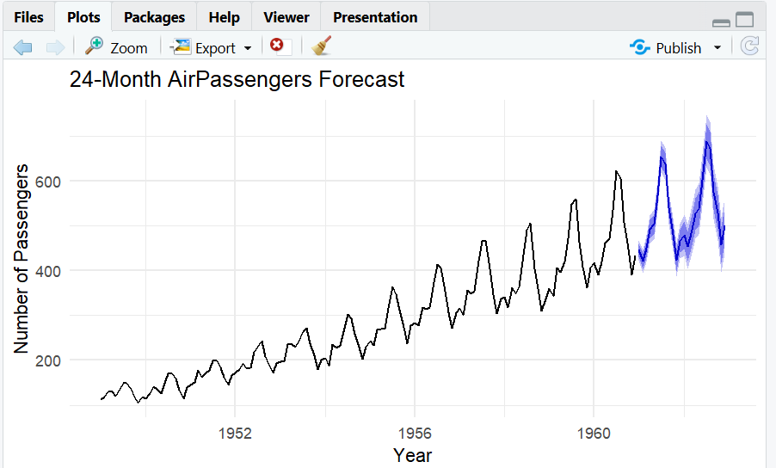

Interpretation
- The ACF shows repeated correlation at intervals associated with the solar cycle.
- The periodogram should show a strong peak corresponding to a cycle of approximately 11 years.
- This agrees well with the commonly cited ~11-year solar activity cycle.

